Improving Teaching and Learning Workshop
(July 01 2016)
Workshop summary
Rita Bencze, PhD
(UD Balásházy János Teacher Training Demonstration Secondary School)
Dr. Magdolna Chrappán
(UD Institute of Educational Studies)

Improving teaching and learning is a complex issue influenced by external and internal, objective and subjective factors
- In general the aim of the project:
  - Improving the achievement of teaching-learning processes by systematic school management activities
  - Modelling the process of revealing problems
  - Striving to identify problems and find solutions together
  - Reflective and adaptive school management approach to supporting teaching-learning

- Aim of the workshop

- introducing the process of analysis that our partner schools could try out in the project
- the main activities of the project were presented
  - recognizing problems
  - analysing them and
  - making suggestions
- Introduction of Central5 competency framework
Team work: 3 tasks done focusing on classroom management, teaching-learning process

II. Special focus of the workshop: Central5 hierarchy of the leader’s competency areas

Leaders’ competences are said to be crucial in successful managing. And it’s an evidence that principals need certain competences and skills to be efficient leaders.
In 2011-12 as a result of an international cooperation among 5 countries, leaders’ standards were accepted it came to be known as the Central5 competency framework and has been applied to evaluate leaders and school leaders since 2014.
And the Institute of Educational Sciences at the University of Debrecen has been using this framework in their school leader and mentor in-service trainings, too.
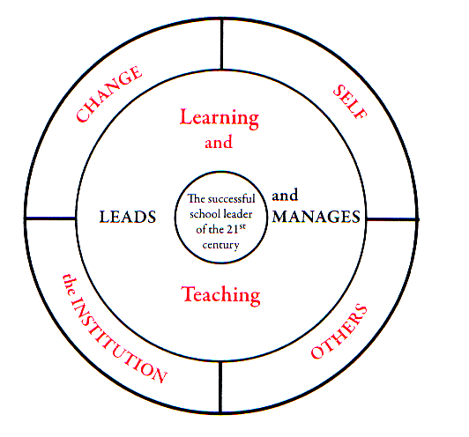
The picture shows the structure of the Central 5 competency areas: it suggests that if a leader and a school leader wants to be successful in the 21st century then he/she has to lead and manage at the same time. In terms of a school: managing teaching and learning are in the center as these are the core activities of a school.

- Conclusions:

- Problem lists from teacher’s and leader’s aspect were similar, with common elements:
- unmotivated students
- discipline problems
- lack of family commitment / disadvanteged family background
From the students’ point of view:
- Less motivating material
- Boring classroom environment
- Teacher centered lessons

Most freequently mentioned problems | Solutions suggested
unmotivated students | - varied methodology,  - peer learning,  - peer coaching,  - rescheduled (student-friendly) timetable,  - more flexible curriculum with more optional subjects for students
behavioural/discipline problems | - self reflection should be enhanced,  - adaptive school environment.  - school as a learning community
Uncertified absence/vagary | - developing whole school culture,  - involving parents  - 21st C classrooms and environment  - school is not only a place for learning, but recreational activities, too.
Unmotivating material | - in-service trainings for teachers,  - IT devices, gamification,  - project work,  - interdisciplinarity,  - everyday topics that raise students’ interest and motivation.  - Teaching-learning should take place in a modern environment that eliminates frontal work and enhances other innovative, creative ways of learning  - original teacher-student roles should be replaced by tutorial type of system.

Tasks solved in the workshop: see on ppt

Participants
Kovács Árpádné Molnár Judit kovacsne.molnarj@gmail.com
Kunkli Erzsébet kunkli.zsoka@gmail.com
Éll Ninetta ellninetta@gmail.com
Buglyó-Kósik Anikó kosikani@freemail.hu
Isabel Estevinha isaestevinha@gmail.com
Tatyana Stamova tas1104@abv.bg
Dobi Judit dobijudit01@gmail.com
Maria Paiva mjspaiva@gmail.com
Gálné Tar Gyöngyi targyongyi@gmail.com
Daniela Ivanova dani.n.todorova@zaednovchas.bg
Bogdanka Mihaylova boginm.gl@abv.bg
Karcza Ildikó karczaildiko@gmail.com
Jónásné Garai Margit jonasnegaraimargit@gmail.com
Császi Anikó csaszianiko69@gmail.com
Evald Sepp evald.sepp@gmail.com
Kristina Rangelova k.rangelova@gmail.com
Helen Paju hlntreial@gmail.com
Szücs Gábor igorgaben@gmail.com
Vladimir Nikolov v.nikolov@zaednovchas.bg
Siivi Jönuri huvijuht@sjk.u.ee
Szőllősi Tamás szabtelovtamas@gmail.com
Chrappán Magdolna chrappanm@gmail.com
Zsupos Gabriella dioteadb@freemail.hu
Nemes Róbertné sagimarcsi@gmail.com
Kónya Bettina bettina.konya@gmail.com
Buzsik Beáta bea116@freemail.hu
Biri Sándorné birisne@gmail.com
Rácz Nikoletta kicsikiba@gmail.com
Aranyi Fruzsina aranyifr@gmail.com
Csekéné Molnár Erika mol.erika@gmail.com
Birtáné Karádi Erika birtaneri66@gmail.com
Vass Vilmos drvassvilmos@gmail.com
Tihomiv Aleksiev t.aleksiev@zaednovchas.bg
Kcarrie Valentine kcarrie.valentine@ascl.org.uk
Carla Ferro carlaferro@carlaferro@prof.aeaa.pt
Marina Nunes marina.sousanunes@gmail.com
Ralitsa Kotseva r.koceva@zaednovchas.bg

